* TESTING STRATEGIES

Software testing is a process of ensuring acceptable degree of quality attributes of software. Testing is the process of finding the errors introduced at any stage of development.

There are various testing strategies which are made for different software testing like static and dynamic analysis, different types of testing like black -box, white -box. There are different levels of testing which are applied during testing of software.

LEVELS OF TESTING

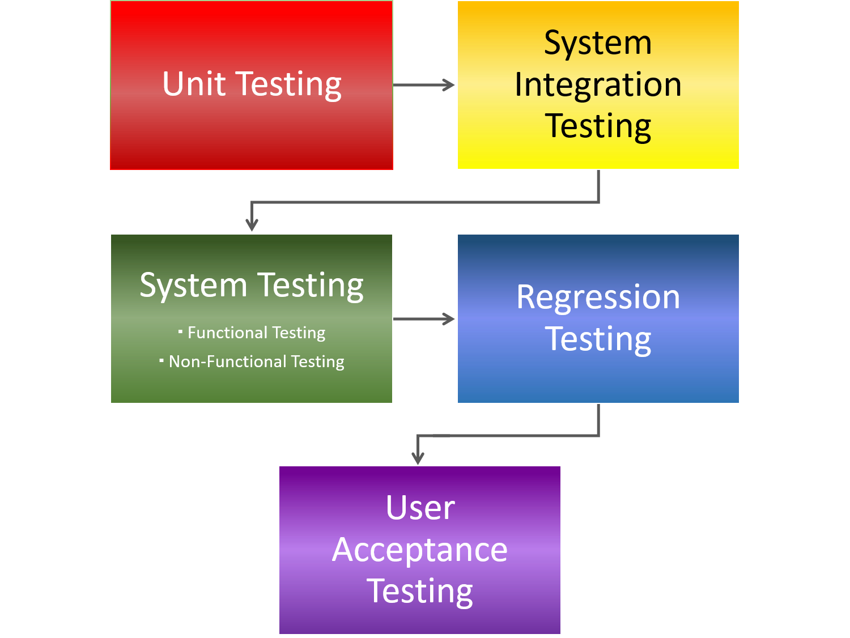

For implementation of any project testing is necessary, as in our **NUMERICAL GAME PUZZLE** we need to test whether our game is error free and well organized or not.

Game testing is the most important part in a game development process. This is the final component that analyses whether your gaming application is ready for launch or not. Such services give the development process a critical eye to focus on constant searches  like inconsistencies, errors, coherence and completeness, etc.

Every software is tested differently based on its model and stage of development.

For **NUMERICAL GAME PUZZLE** testing strategies applied would be-

**1.** **DYNAMIC ANALYSIS** – For dynamic testing the test objects are executed or simulated. Dynamic analysis is what is generally considered as testing i.e. it involves running the system which is very important for our game automation because it deals with whether the application is working according to the specifications and for this the testers look for game play issues, graphics issues, audio-visual issues, etc. Also validates whether installation goes smoothly, the app works in minimized mode, the app allows social networking options, supports payment gateways, and many more. So dynamic analysis is preferred over static analysis.

The activities for dynamic testing are-

1. Preparation of the test object for error localization.

2. Availability of a test environment.

3. Selection of appropriate test cases and data.

4. Test execution and evaluation.

In this way dynamic analysis is performed.

**2. Black-box Testing** – Functional or black-box testing is an approach to testing where the tests are derived based on the requirements or specifications of the program or module and the internals of the program are not considered. Functional testing refers to testing which involves mainly observation of the output for some input and there is no attempt to analyses the code, which produces the output.

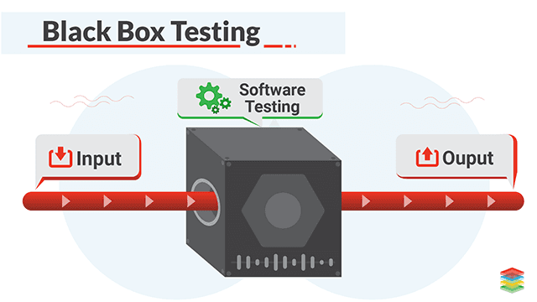

For **NUMERICAL GAME PUZZLE** black box testing is suitable or a good approach for testing the system as the observation of the output is very necessary or rather, we should say checking the functionality of system is important.

So, for this project this strategy of testing can be applied.